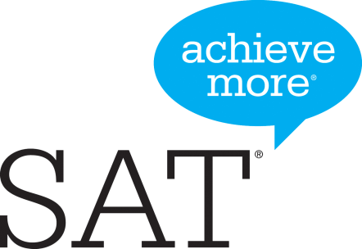**2021-2022 SAT Dates**

**North Shore High School**

**School Code No.: 332-102**

**Saturday Testing Dates**

**Test Dates Registration Deadline Late Registration* Notes**  
August 28, 2021 July 30,2021 Aug. 17, 2021* NOT AT NSHS

**October 2, 2021 Sept. 3, 2021 Sept. 21, 2021* AT NSHS**November 6, 2021 Oct. 8, 2021 Oct. 26, 2021* NOT AT NSHS  
December 4, 2021 Nov. 4, 2021 Nov. 23 2021* NOT AT NSHS  
March 12 2022 Feb. 11, 2022 March 1, 2022* NOT AT NSHS  
**May 7, 2022 April 8, 2022 April 26, 2022* AT NSHS**  
June 4, 2022 May 5, 2022 May 25, 2022* NOT AT NSHS

**Go to sat.collegeboard.org to register for SAT Testing**

**\*Late Fees Apply**