**2021-22 ACT Dates**

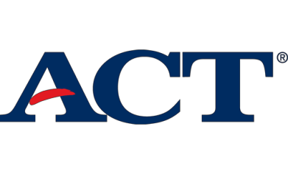**North Shore High School**

**Testing Dates**

**Test Dates Registration Deadline Late Registration * Notes**

|  |  |  |  |
| --- | --- | --- | --- |
| September 11, 2021 | August 6, 2021 | August 20, 2021*NOT AT NSHS | |
| October 23, 2021 | September 17, 2021 | October 1, 2021* **AT NSHS** | |
| December 11, 2021 | November 5, 2021 | November 19, 2021* | NOT AT NSHS |
| February 12, 2022 | January 7, 2022 | January 21, 2022* | NOT AT NSHS |
| **April 2, 2022** | February 25, 2022 | March 11, 2022* | **AT NSHS** |
| June 11, 2022 | May 6, 2022 | May 20, 2022* | NOT AT NSHS |
| July 16, 2022** | June 17, 2022 | June 24, 2022* | NOT AT NSHS |
| *Late Fees will apply |  |  |  |

**The test is not available in New York for the July test date.